
Sukkur IBA University, Khairpur Campus

Lab 1 — Solved Tasks

Task A — Language Classification
Language | Imperative | Declarative | Von Neumann | OOP | Functional | 3GL | 4GL | Scripting
C | ✓ |  | ✓ |  |  | ✓
Lisp |  |  |  |  | ✓ | ✓
C++ | ✓ |  | ✓ | ✓ |  | ✓
ML |  |  |  |  | ✓ | ✓
COBOL | ✓ |  | ✓ |  |  | ✓
FORTRAN | ✓ |  | ✓ |  |  | ✓
Perl | ✓ |  |  |  |  | ✓ |  | ✓
Python | ✓ |  |  | ✓ | ✓ | ✓ |  | ✓
Java | ✓ |  | ✓ | ✓ |  | ✓
VB | ✓ |  | ✓ | ✓ |  | ✓
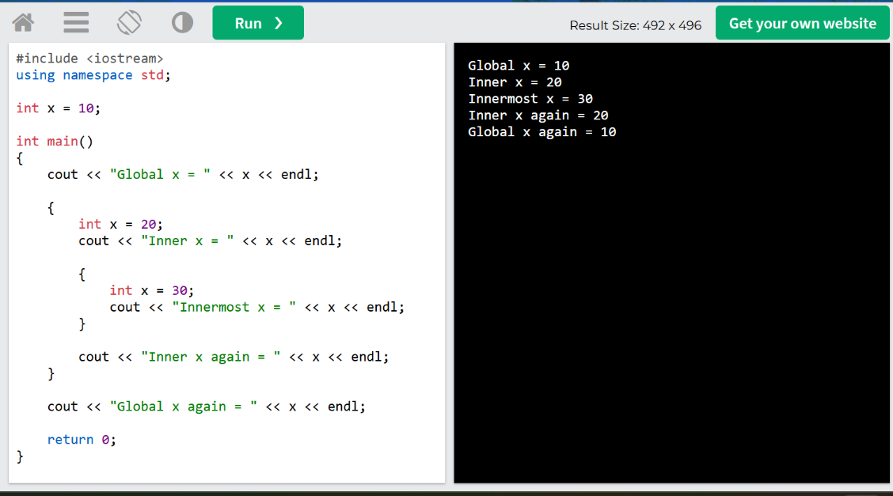

Task B — Scope and Shadowing

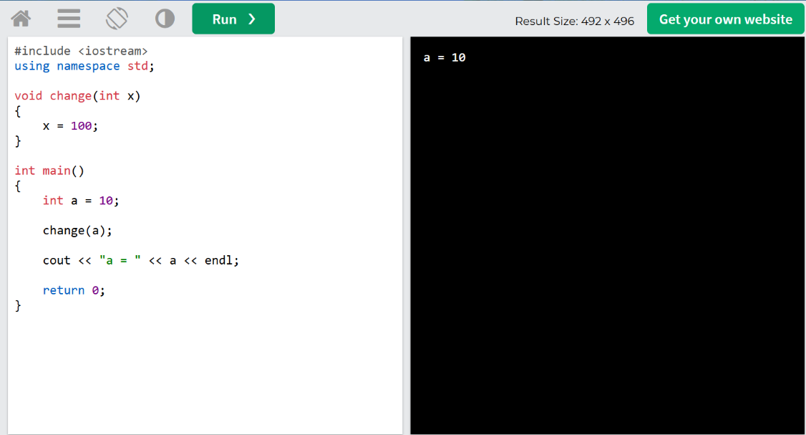

Task C — Pass by Value

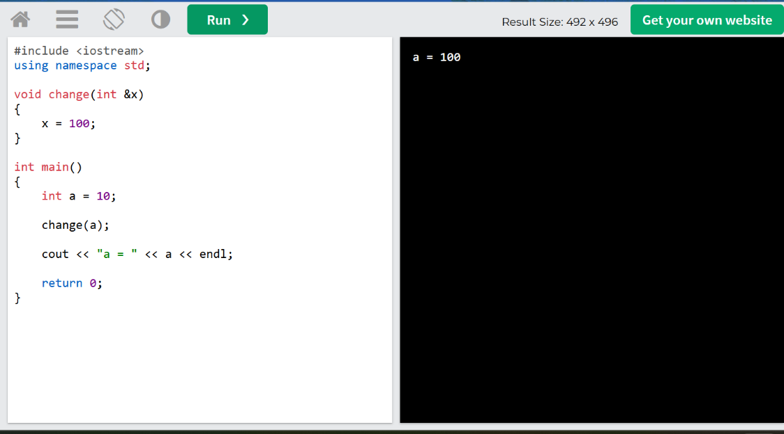

Task D — Pass by Reference

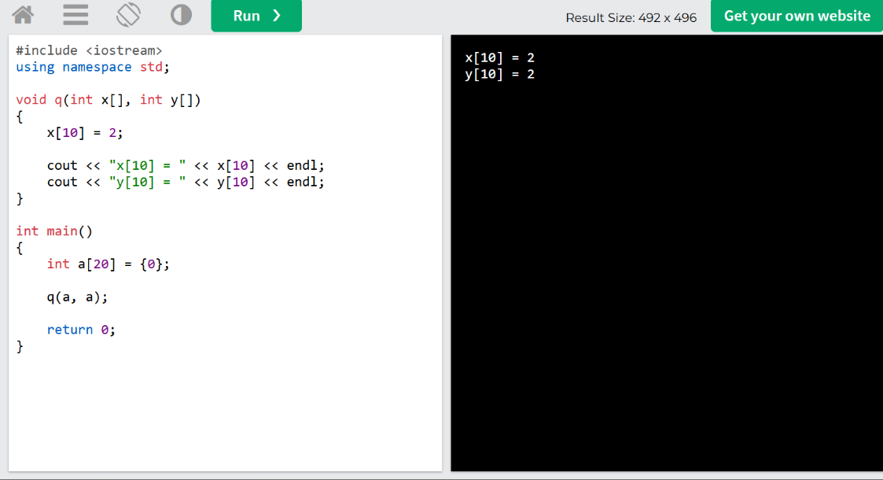

Task E — Pass by Name
procedure P(x)
{
print(x);
}

P(a + b);

Task F — Aliasing

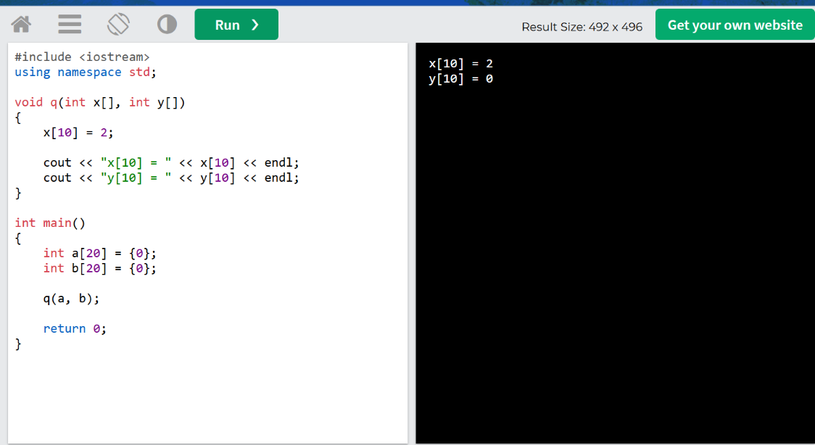

Task G — Macro Expansion

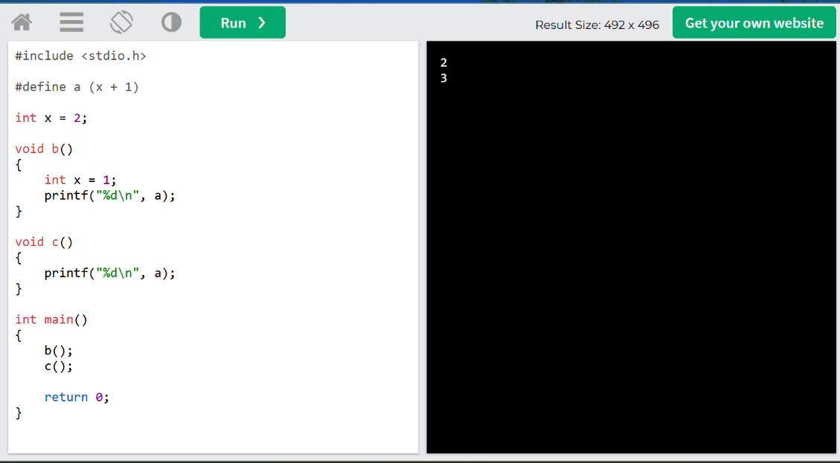

Task H — Compare macro.c and macro.i
macro.c
↓
Preprocessor
↓
macro.i

